Consent to proxy access to GP online services

Note: If the patient does not have capacity to consent to grant proxy access and proxy access is considered by the practice to be in the patient’s best interest section 1 of this form may be omitted.

Section 1
I,………………………………………………….. (name of patient), give permission to my GP practice to give the following people ….………………………………………………………………..…………….. proxy access to the online services as indicated below in section 2.
I reserve the right to reverse any decision I make in granting proxy access at any time.
I understand the risks of allowing someone else to have access to my health records.
I have read and understand the information leaflet provided by the practice

Signature of patient | Date

Section 2
- Online appointments booking
- Online prescription management
- Accessing the medical record for (name of patient)

Section 3
I/we…………………………………………………………………………….. (names of representatives) wish to have online access to the services ticked in the box above in section 2
for ……………………………………….……… (name of patient).
I/we understand my/our responsibility for safeguarding sensitive medical information and I/we understand and agree with each of the following statements:
- I/we have read and understood the information leaflet provided by the practice and agree that I will treat the patient information as confidential
- I/we will be responsible for the security of the information that I/we see or download
- I/we will contact the practice as soon as possible if I/we suspect that the account has been accessed by someone without my/our agreement
- If I/we see information in the record that is not about the patient, or is inaccurate, I/we will contact the practice as soon as possible. I will treat any information which is not about the patient as being strictly confidential

Signature/s of representative/s | Date/s

The patient
(This is the person whose records are being accessed)
Surname | Date of birth
First name

Address

Postcode
Email address
Telephone number | Mobile number

I have understood and will adhere to the practice policy for the use of on-line booking. I understand that failure on my part to adhere to the policy may result in my on-line booking registration being terminated. I understand that this will in no way affect my registration with the Practice.
The representatives
(These are the people seeking proxy access to the patient’s online records, appointments or repeat prescription.)
Proxy 1 Proxy 2
Surname | Surname
First name | First name
Date of birth | Date of birth
Address  Postcode | Address (tick if both same address )  Postcode
Email | Email
Telephone | Telephone
Mobile | Mobile

Confirmation of Identification of Proxy 1
Patient NHS number |  | EMIS Number of Patient
Identity verified by (initials of Practice member) | Date | Method of ID confirmation  Vouching □  Vouching with information in record □  Photo ID and proof of residence □
Confirmation of Identification of Proxy 2
Identity verified by (initials of Practice member) | Date | Method of ID confirmation  Vouching □  Vouching with information in record □  Photo ID and proof of residence □

Confirmation of Identification of Patient
Patient NHS number |  | EMIS Number of Patient
Identity verified by (initials of Practice member) | Date | Method of ID confirmation  Vouching □  Vouching with information in record □  Photo ID and proof of residence □
Approval of Application (by Lead GP)
Authorised by |  |  | Date
Date account created

Date account password details printed
Level of record access enable (Please Tick one option)

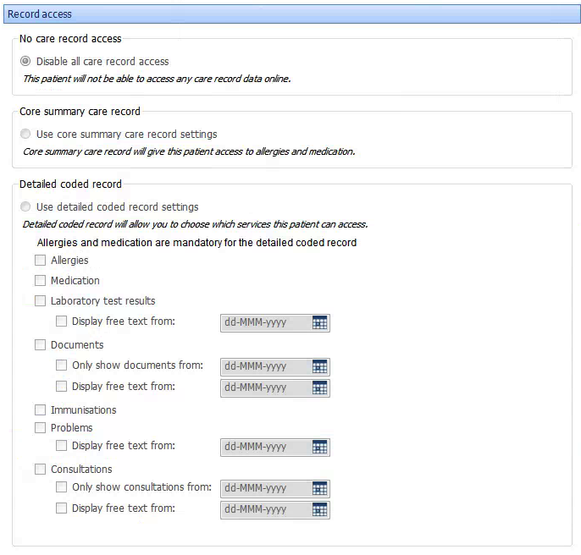

Notes/Explanation:

PRACTICE POLICY FOR ONLINE APPOINTMENT BOOKING

Before you begin to use the online booking service, please read the following policy and attached agreement regarding the booking of appointments over the internet. Please keep this policy for your own reference.

A document containing your pin number and log-on details will be provided to you as soon as the practice receives your signed consent form. Please keep this document safe as it contains your personal information.

When registered you will be able to:
- Find available doctor appointment slots
- Book new appointments. Appointments may be booked up to a maximum of 21 days ahead
- View appointments you have already booked
- Cancel appointments

Doctors Appointments
Please ensure that you book your appointments appropriately. If you are unsure as to whether it is appropriate for you to see a doctor, contact us by telephone. Whilst we will do what we can for you to see the doctor of your choice this may not always be possible due to unforeseen circumstances, for instance if the doctor is on sick leave or annual leave.

Missed Appointments
If you are unable to attend your appointment please let us know as early as possible. You may cancel it online or telephone us. This will allow us to offer the appointment to another patient.

We will be monitoring missed appointments on a regular basis. If you miss an appointment more than twice in one year we will remove the facility for you to use online booking, but you will still be able to book appointments with our receptionists.

Inappropriate use
We are sure you will find this service useful. However, we will revoke your access to it if you abuse the service. For your access to be reinstated you must liaise with our reception team.

Examples of what we would consider inappropriate use are:
- Booking appointments and not using them more than twice a year
- Booking appointments for other family members using your name.
- Consistently booking inappropriate appointments with the doctor

Appointments for Family Members:
Unfortunately the system is not flexible enough to allow you to book appointments for family members.

Under 16s: Online booking is only available to patients aged 16 and over.

Patient Agreement to Practice Policy
For the use of On-line Booking

Patient Name:
DoB:
Address

- I have understood and will adhere to the practice policy for the use of online booking.

- I understand that failure on my part to adhere to the policy may result in my online booking registration being terminated.

- I understand that this will in no way affect my registration with the practice.

Signed:
Date:

Consent Form – Patient Care Text Messaging

Declaration

I consent to the practice contacting me by text message for the purposes of health promotion and for appointment reminders.

I acknowledge that appointment reminders by text are an additional service and that these may not take place on all / or on any occasion, and that the responsibility of attending appointments or cancelling them still rests with me. I can cancel the text message facility at any time.

The surgery does not offer a reply facility to enable patient to respond to texts directly.

Although text messages are generated using a secure facility, I understand that they are transmitted over a public network onto a personal telephone. As such they may not be secure, and therefore the practice will not transmit any information which would enable an individual patient to be identified.

I agree to advise the practice if my mobile number changes or if this is no longer in my possession.

Patient Name:
Date of Birth:
Mobile Number:
Signed:
Date:

The practice does not share mobile phone contact details with any
external organisation.

